**A**

**Project Report**

**On**

**"ONLINE AIRLINE MANAGEMENT SYSTEM"**

**Prepared by**

Keval Patel (20DIT057)

Preshna Patel (20DIT063)

Riya Patel (20DIT064)

Niyati Shah (20DIT086)

**Under the guidance of**

Prof. Rima Patel

Prof. Ritika Jani

A Report Submitted to

Charotar University of Science and Technology

for Partial Fulfillment of Requirements for the

Degree of Bachelor of technology(B.Tech)

Information Technology

4th Semester Software Group Project-II (IT258)

**Submitted at**



**Department of Information Technology**

**DEPSTAR**

**At: Changa, Dist: Anand – 388421**

**April 2021**



**CERTIFICATE**

This is to certify that the report entitled “**Online Airline Management System**” is a bonafide work carried out by **Mr. Keval Patel(20DIT057)** under the guidance and supervision of **Assistant Prof. Rima Patel** for the subject IT258)-**Software Group Project-II** (Information Technology) of 4th Semester of Bachelor of Technology at Faculty of Technology & Engineering – **DEPSTAR**, CHARUSAT, Gujarat.

To the best of my knowledge and belief, this work embodies the work of candidate himself, has duly been completed, and fulfills the requirement of the ordinance relating to the B.Tech. Degree of the University and is up to the standard in respect of content, presentation and language for being referred to the examiner.

|  |  |
| --- | --- |
| Rima Patel  Assistant Professor cum Research Fellow  Computer Science & Engineering  DEPSTAR, Changa, Gujarat. |  |
| Dr. Amit J. Nayak  Head of Department – Information Technology, DEPSTAR  CHARUSAT, Changa, Gujarat. | Dr. Amit P. Ganatra  Principal, DEPSTAR  Dean, FTE  CHARUSAT, Changa, Gujarat. |

**Devang Patel Institute of Advance Technology And Research At: Changa, Ta. Petlad, Dist. Anand, PIN: 388 421. Gujarat**



**CERTIFICATE**

This is to certify that the report entitled “**Online Airline Management System**” is a bonafide work carried out by **Ms. Preshna Patel(20DIT063)** under the guidance and supervision of **Assistant Prof. Rima Patel** for the subject IT258)-**Software Group Project-II** (Information Technology) of 4th Semester of Bachelor of Technology at Faculty of Technology & Engineering – **DEPSTAR**, CHARUSAT, Gujarat.

To the best of my knowledge and belief, this work embodies the work of candidate himself, has duly been completed, and fulfills the requirement of the ordinance relating to the B.Tech. Degree of the University and is up to the standard in respect of content, presentation and language for being referred to the examiner.

|  |  |
| --- | --- |
| Rima Patel  Assistant Professor cum Research Fellow  Computer Science & Engineering  DEPSTAR, Changa, Gujarat. |  |
| Dr. Amit J. Nayak  Head of Department – Information Technology, DEPSTAR  CHARUSAT, Changa, Gujarat. | Dr. Amit P. Ganatra  Principal, DEPSTAR  Dean, FTE  CHARUSAT, Changa, Gujarat. |

**Devang Patel Institute of Advance Technology And Research At: Changa, Ta. Petlad, Dist. Anand, PIN: 388 421. Gujarat**

**CERTIFICATE**

This is to certify that the report entitled “**Online Airline Management System**” is a bonafide work carried out by **Ms. Riya Patel(20DIT064)** under the guidance and

supervision of **Assistant Prof. Rima Patel** for the subject IT258)-**Software Group Project-II** (Information Technology) of 4th Semester of Bachelor of Technology at Faculty of Technology & Engineering – **DEPSTAR**, CHARUSAT, Gujarat.

To the best of my knowledge and belief, this work embodies the work of candidate himself, has duly been completed, and fulfills the requirement of the ordinance relating to the B.Tech. Degree of the University and is up to the standard in respect of content, presentation and language for being referred to the examiner.

|  |  |
| --- | --- |
| Rima Patel  Assistant Professor cum Research Fellow  Computer Science & Engineering  DEPSTAR, Changa, Gujarat. |  |
| Dr. Amit J. Nayak  Head of Department – Information Technology, DEPSTAR  CHARUSAT, Changa, Gujarat. | Dr. Amit P. Ganatra  Principal, DEPSTAR  Dean, FTE  CHARUSAT, Changa, Gujarat. |

**Devang Patel Institute of Advance Technology And Research At: Changa, Ta. Petlad, Dist. Anand, PIN: 388 421. Gujarat**



**CERTIFICATE**

This is to certify that the report entitled “**Online Airline Management System**” is a bonafide work carried out by **Ms. Niyati Shah(20DIT086)** under the guidance and supervision of **Assistant Prof. Ritika Jani** for the subject IT258)-**Software Group Project-II** (Information Technology) of 4th Semester of Bachelor ofTechnology at Faculty of Technology & Engineering – **DEPSTAR**, CHARUSAT, Gujarat.

To the best of my knowledge and belief, this work embodies the work of candidate himself, has duly been completed, and fulfills the requirement of the ordinance relating to the B.Tech. Degree of the University and is up to the standard in respect of content, presentation and language for being referred to the examiner.

|  |  |
| --- | --- |
| Ritika Jani  Teaching cum Research Assistant  Department of Information Technology And,  Research(DEPSTAR)  CHARUSAT,Changa, Gujarat. |  |
| Dr. Amit J. Nayak  Head of Department – Information Technology, DEPSTAR  CHARUSAT, Changa, Gujarat. | Dr. Amit P. Ganatra  Principal, DEPSTAR  Dean, FTE  CHARUSAT, Changa, Gujarat. |

**Devang Patel Institute of Advance Technology And Research At: Changa, Ta. Petlad, Dist. Anand, PIN: 388 421. Gujarat**

# **ACKNOWLEDGEMENT**

We, the developer of Online Airline Management System, with immense pleasure and commitment would like to present the project assignment. The development of this project has given me wide opportunity to think, implement and interact with various aspects of management skills as well as the new emerging technologies.

Every work that one completes successfully stands on the constant encouragement, good will and support of the people around. We hereby avail this opportunity to express my gratitude to number of people who extended their valuable time, full support and cooperation in developing the project.

We express deep sense of gratitude towards our Head of the IT Department, Dr. Amit Nayak and project guides Prof. Rima Patel and Prof. Ritika Jani for the support during the whole session of study and development. It is because of them, that We was prompted to do hard work, adopting new technologies.

20DIT057 Keval Patel

20DIT063 Preshna Patel

20DIT064 Riya Patel

20DIT086 Niyati Shah

# **ABSTRACT**

This Report presents the design and implementation of a Online Airline management system for a web environment. It will enable users and admin to manage the this website efficiently. It is a Website for any travel booking, which is uniquely designed so that all the users as well as administration can deal with their work on a single Platform. This website makes the admin’s work easy by registering users, it also helps the admin in managing their accounts, Users are given full travel package in our website from ticket booking facilities to Hotel booking , bus booking facility, Administration can easily maintain records of all the users and can also manage flight booking list. The article will describe both the system and the specific differences from other software.

# **TABLE OF CONTENTS**

**List of tables ..................................................................................................... 5**

**Chapter 1 Project Definition.......................................................................... 9**

**Chapter 2 Description...................................................................................... 11**

**Chapter 3 Software and Hardware Requirement......................................... 13**

**Chapter 4 Major Functionality........................................................................15**

**Chapter 5 Gantt Chart/flow chart.................................................................. 17**

**Chapter 6 Project Outcomes............................................................................20**

**Chapter 7 Screenshot of Project Output.........................................................22**

**Chapter 8 Future Enhancements ....................................................................37**

**Refrences............................................................................................................39**

**Chapter -1**

**Project Definition**

# **PROJECT DEFINITION**

Airline management system help users to book tickets without going physically at airport. And this platform is best for advance booking, and provide facilities to book hotels and cab. It is user friendly graphical interface helps users to interact with the system and meet their requirements in just few clicks.

**Chapter- 2**

**Project Description**

**PROJECT DESCRIPTION**

The system proposed has many advantages. The proposed system is highly secured, because for login the system it requires the username and password which is different for each department therefore providing each department a different view of the customer information. It provides wide range of certain criteria in each window the client is working for better and quicker solution. It maintains report for all criteria.

Manages user information separately for all booking types and employee information separately for considering the requirements of website. This system can run on any windows operating system.

The proposed system is managed by the visual studio 16.19.3, PHP 8.0.3, Mysql 8.0 which are user friendly software for every developer and for maintaining the

database XAMPP is used.

**Chapter- 3**

**Software and Hardware Requirement**

**SOFTWARE AND HARDWARE REQUIREMENTS**

**Hardware Requirements :**

* 4 GB RAM minimum, 8 GB RAM recommended
* Processor: i3(laptop or pc)
* Operating System: Windows 10, Android 6 or up
* Internal hard disk: 500 GB Hard disk(laptop or pc)

**Software Requirements:**

* Platform : Visual Studio Code (Version: 16.19.3),

XAMPP (Version: 8.0.3)

* Language : HTML, CSS, JavaScript, PHP
* Backend : MySQL, PHP

**Chapter- 4**

**Major Functionalities**

**MAJOR FUNCTIONALITIES**

The main functions of the application are as follows :

* **ADMIN :**
* Admin can maintain the records of users and flight booking page.
* Admin can generate the ticket.
* Admin gets the feedbacks from their users as well as new

Inquiries.

* **USER :**
* Users can search for flights, hotel, bus booking at any time.
* Users can also download their ticket after booking.

**Chapter- 5**

**Gantt Chart**

**And**

**Flowchart**

**GANTT CHART**

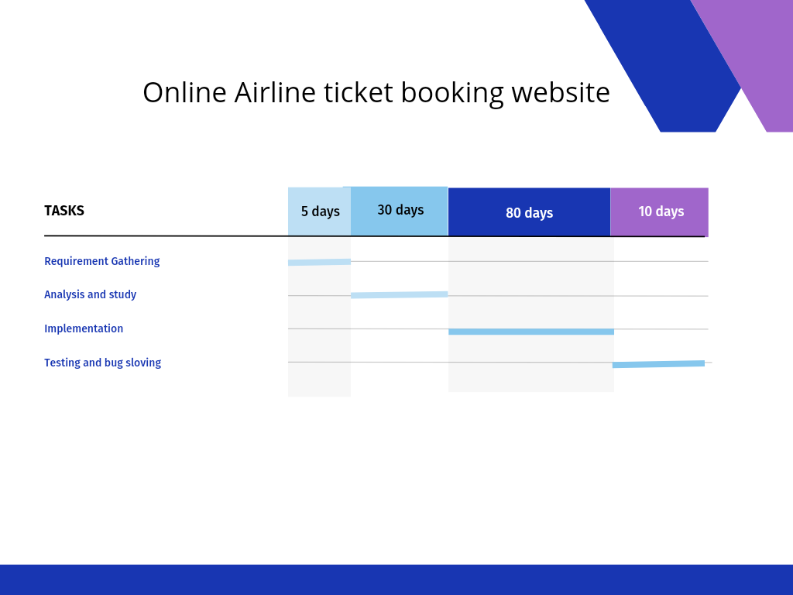

fig 5. 1 Gantt Chart

**FLOWCHART**

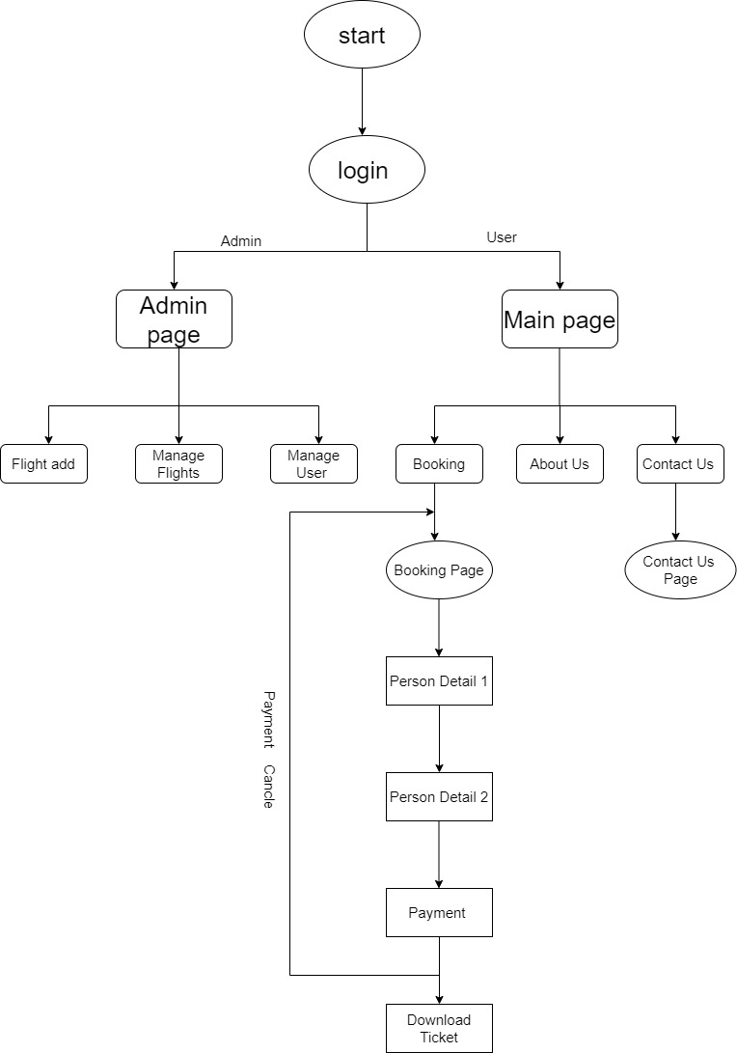

fig 5. 2 Flowchart

**Chapter- 6**

**Project Outcomes**

**PROJECT OUTCOMES**

* It saves time for users.
* Easy interaction on chatbot when needed any help.
* User friendly.
* Registration and login process doesn’t take much time.
* Mobile responsive.

**Chapter- 7  
 Screenshots of Project**

**SCREENSHOTS OF PROJECT**

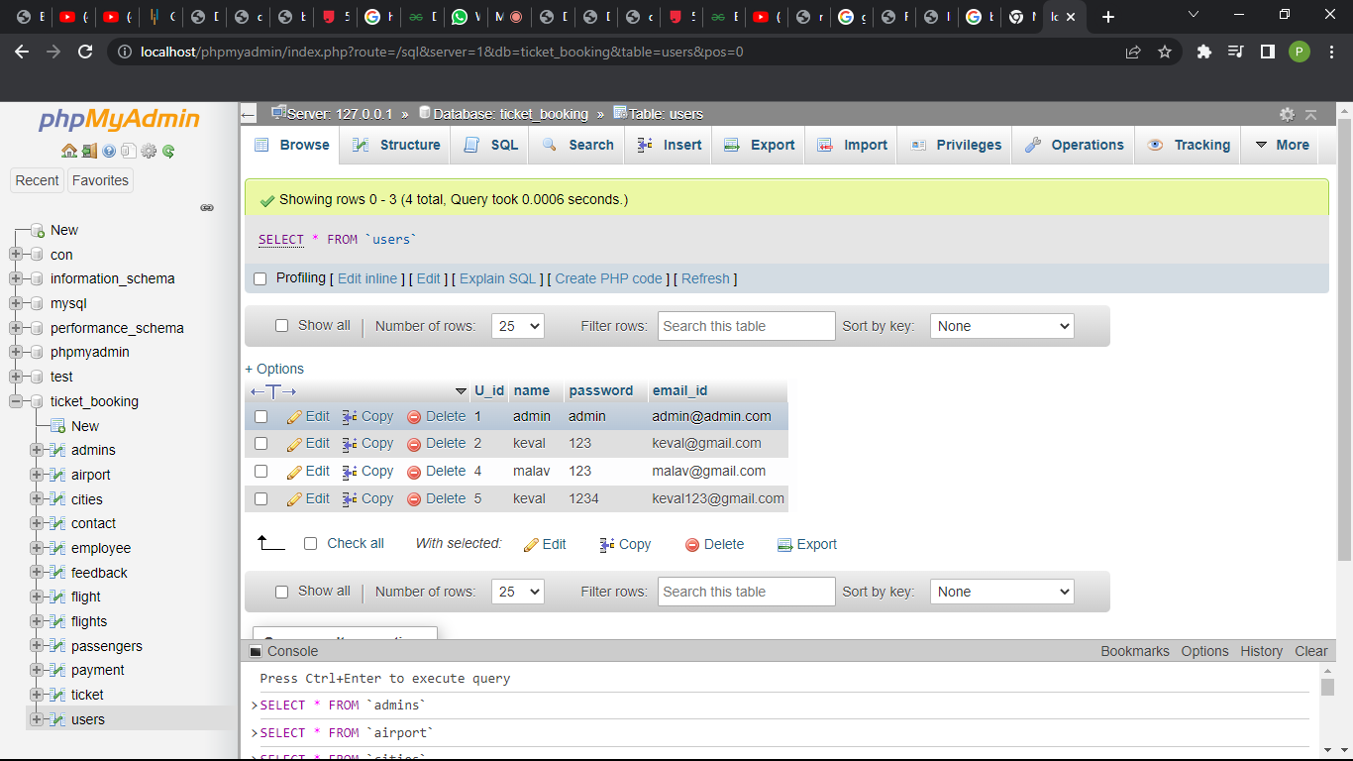

fig 7. 1 user database

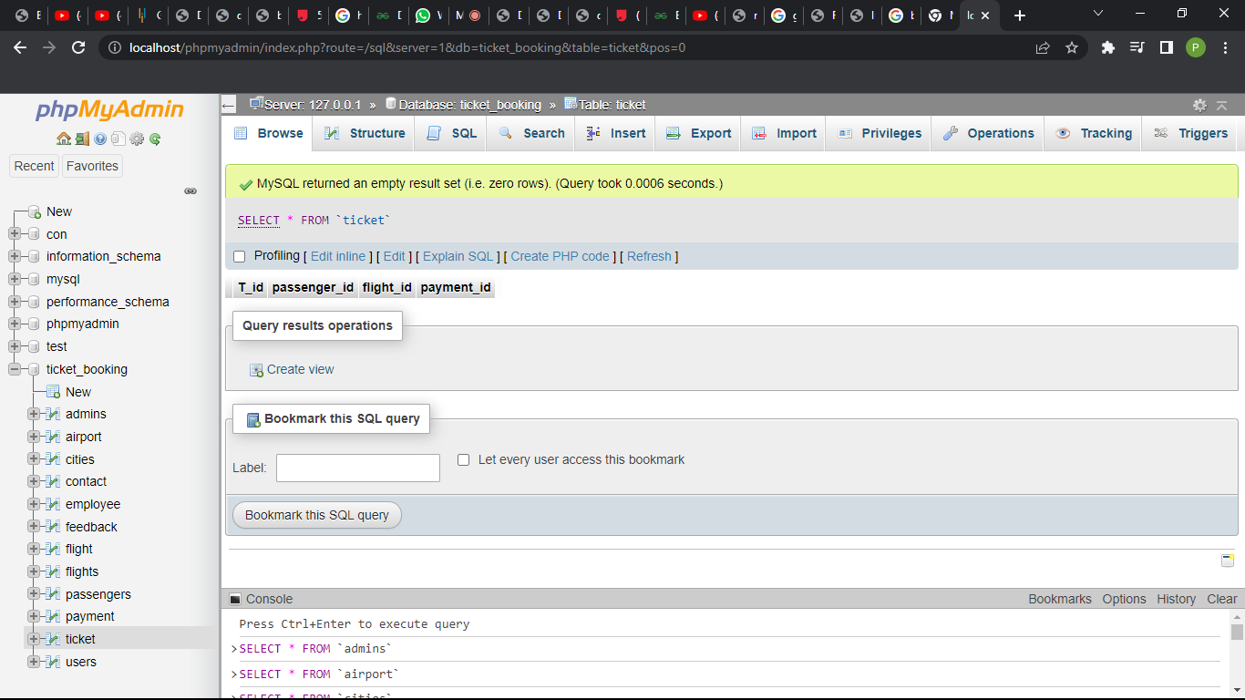

fig 7. 2 ticket database

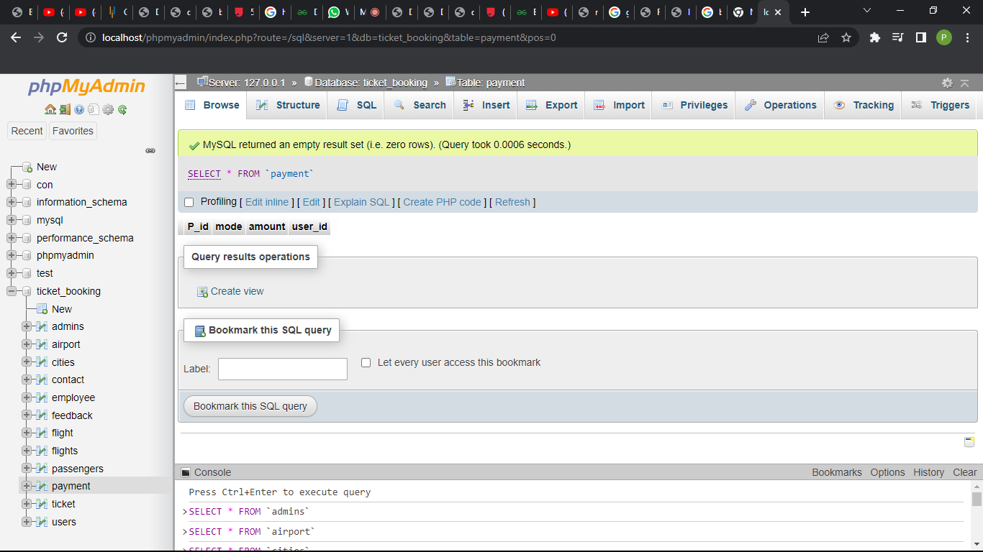

fig 7. 3 payment database

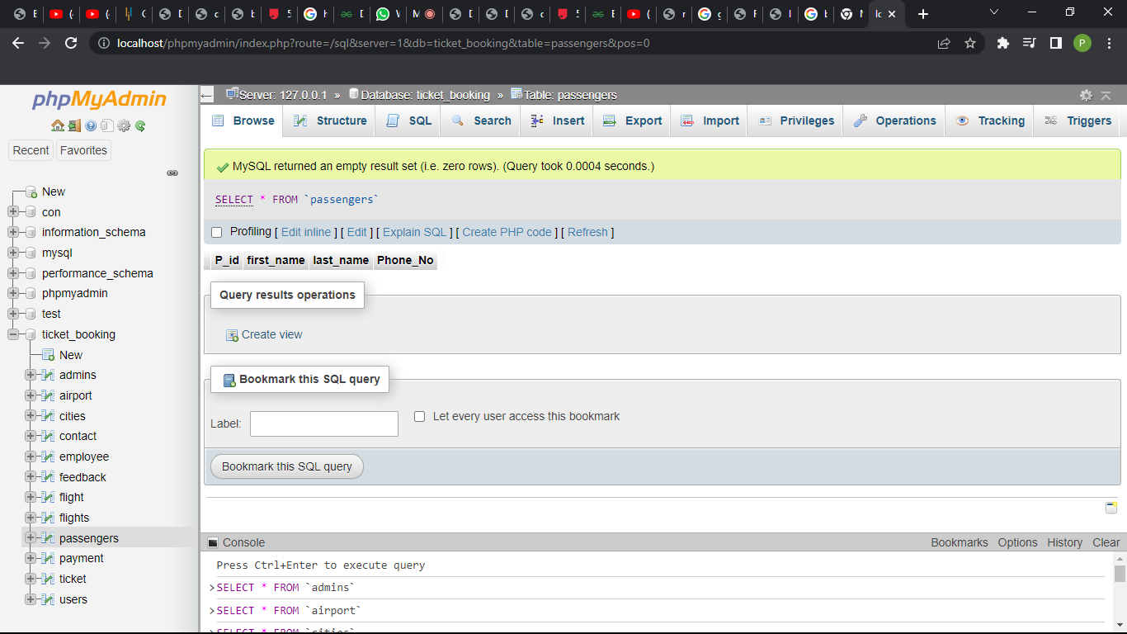

fig 7. 4 passengers database

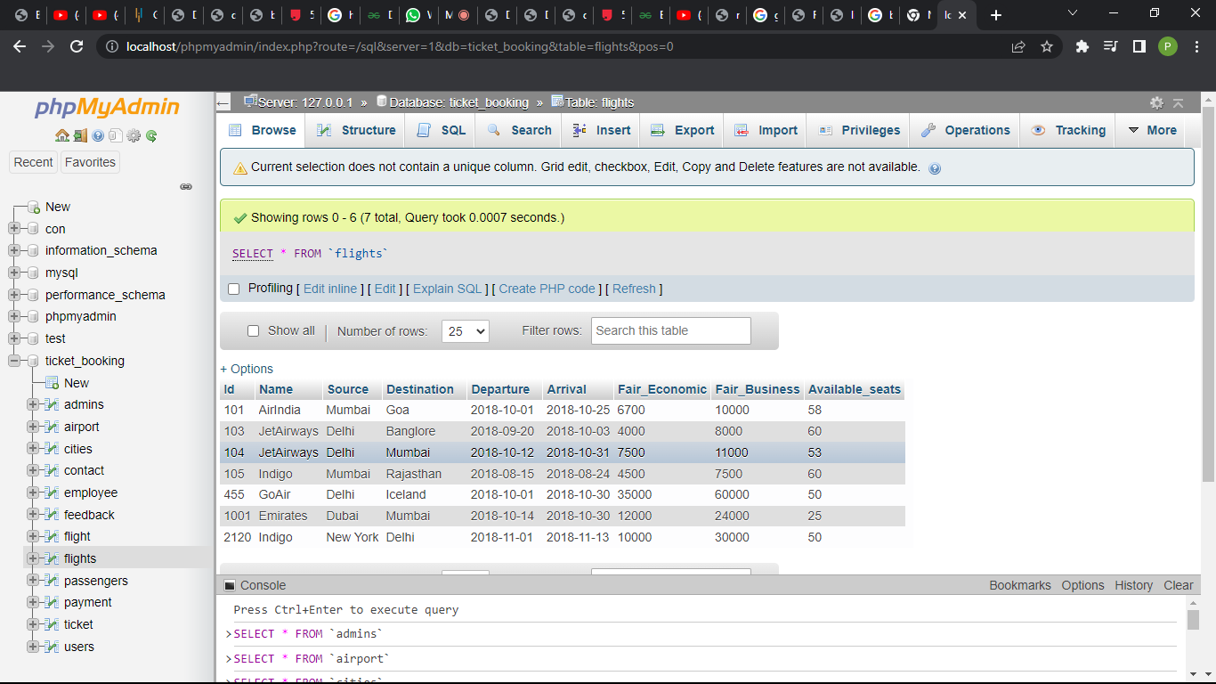

fig 7. 5 flights database

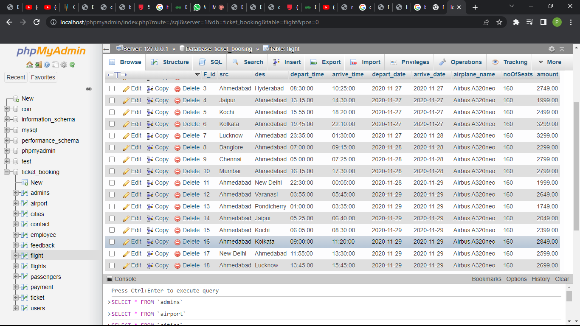

fig 7. 6 flight database

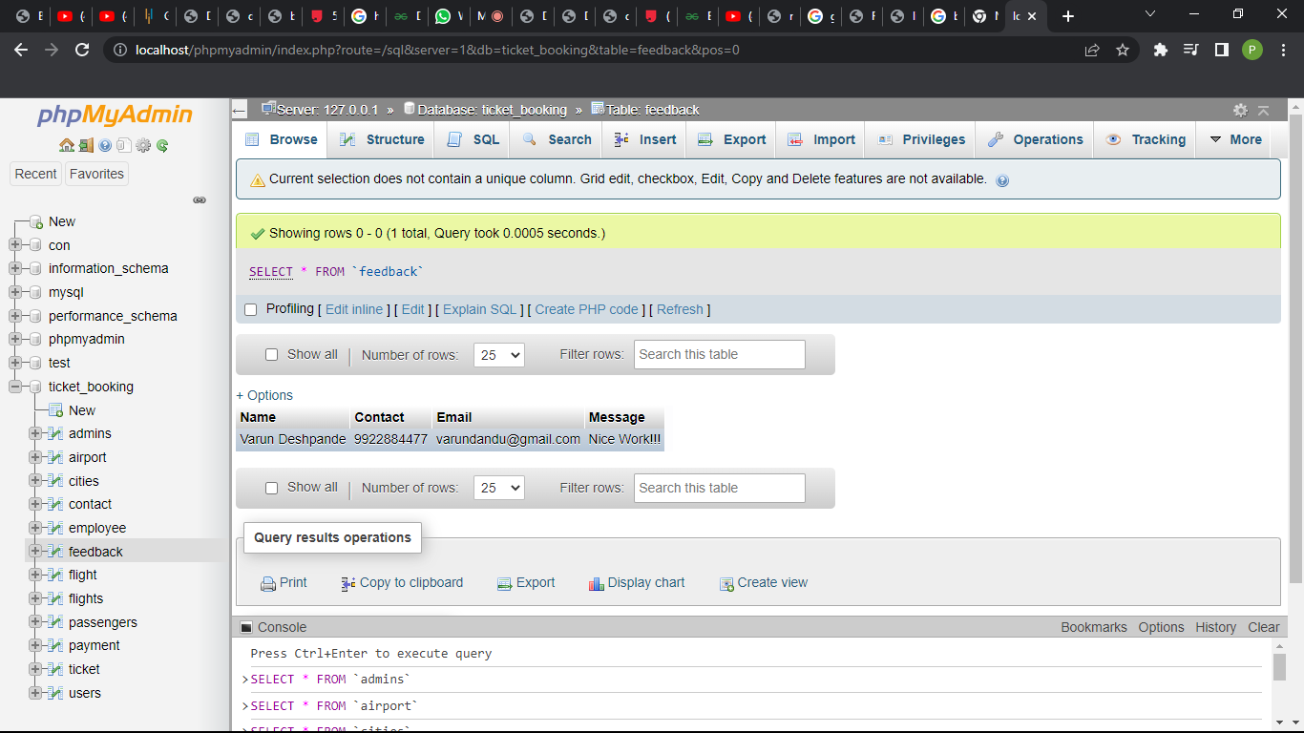

fig 7. 7 feedback database

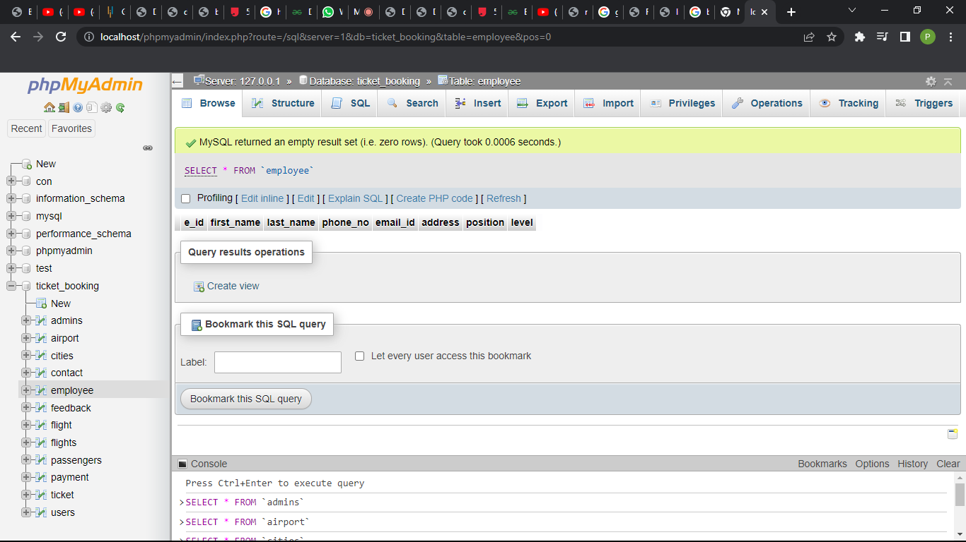

fig 7. 8 employee database

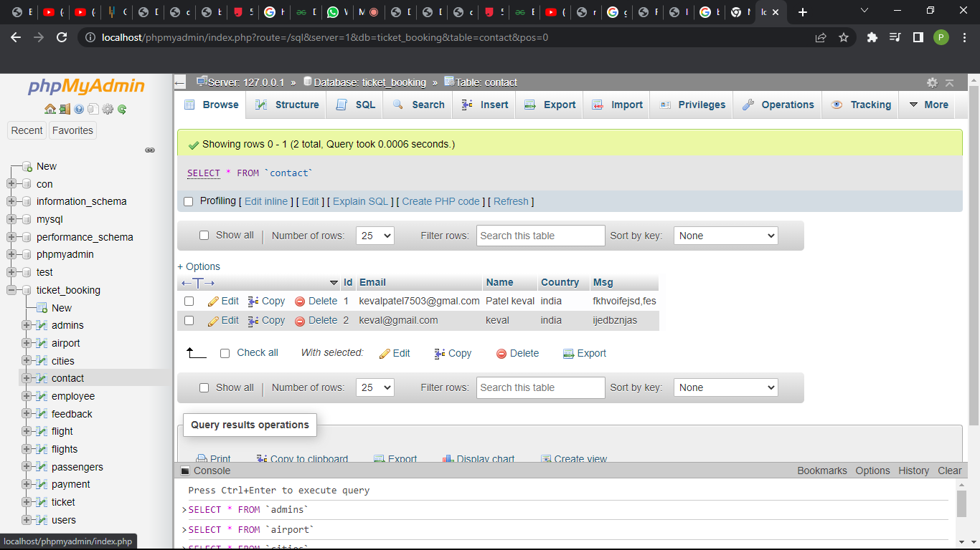

fig 7. 9 contact feedback

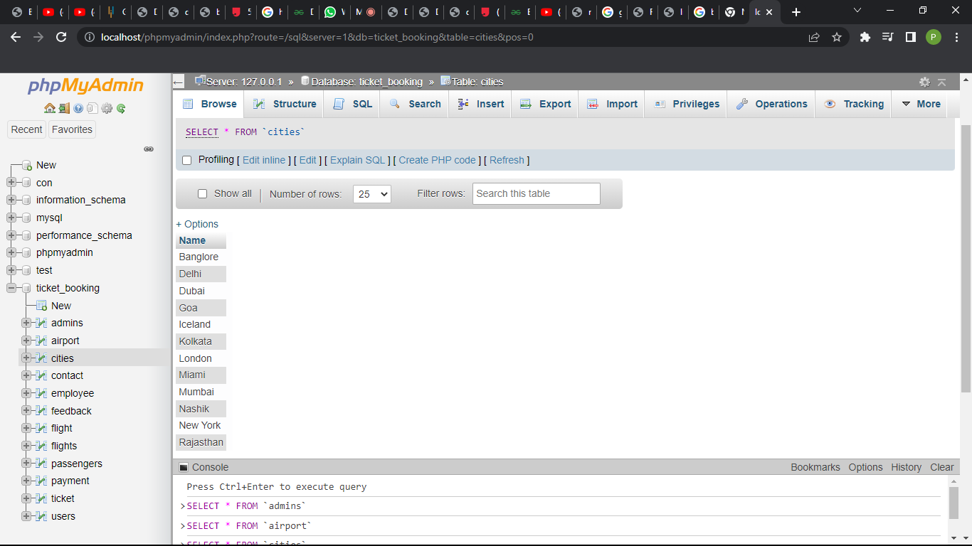

fig 7. 10 cities database

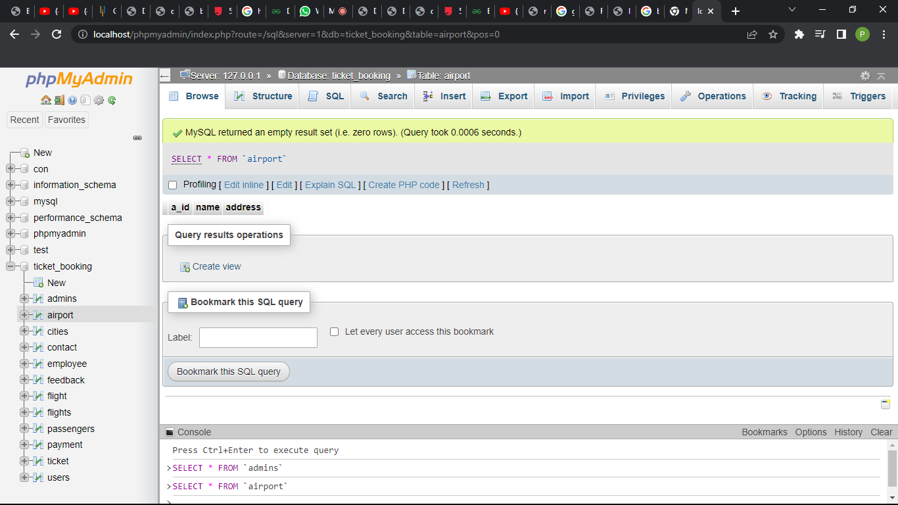

fig 7. 11 airport databse

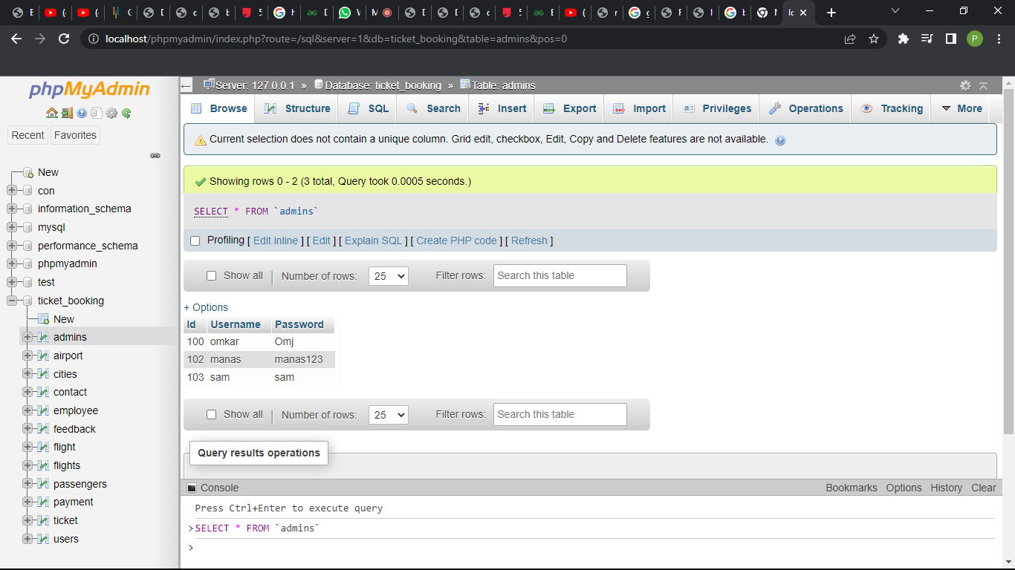

fig 7. 12 admin database

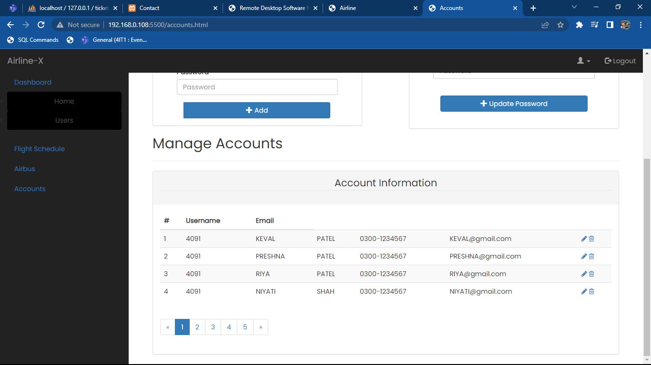

fig 7. 13 admin dashboard

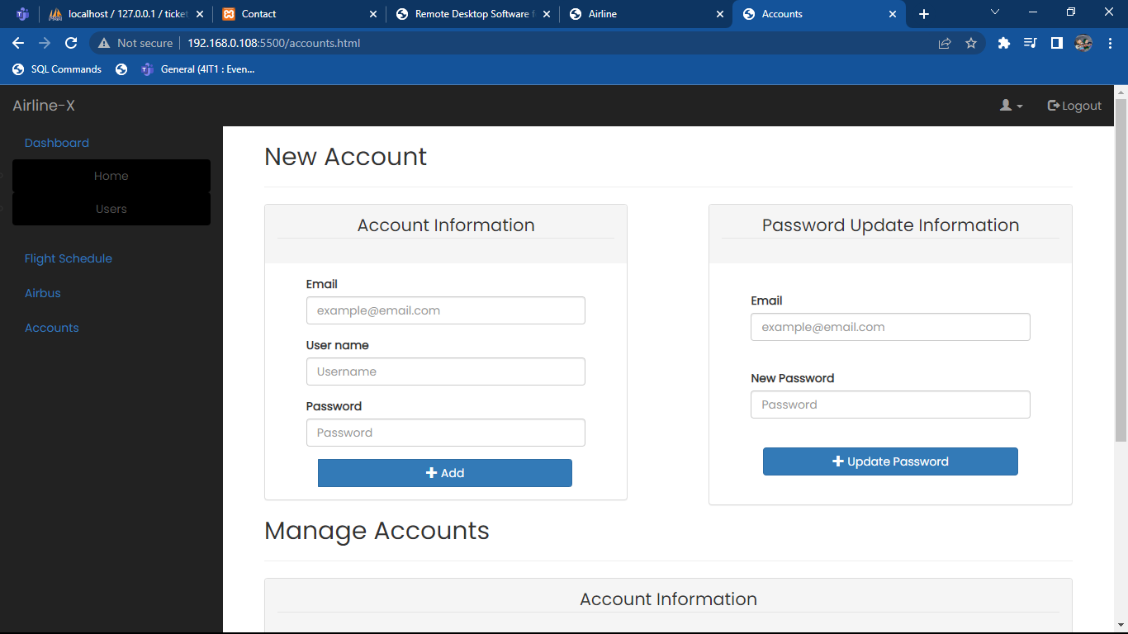

fig 7. 14 account managment

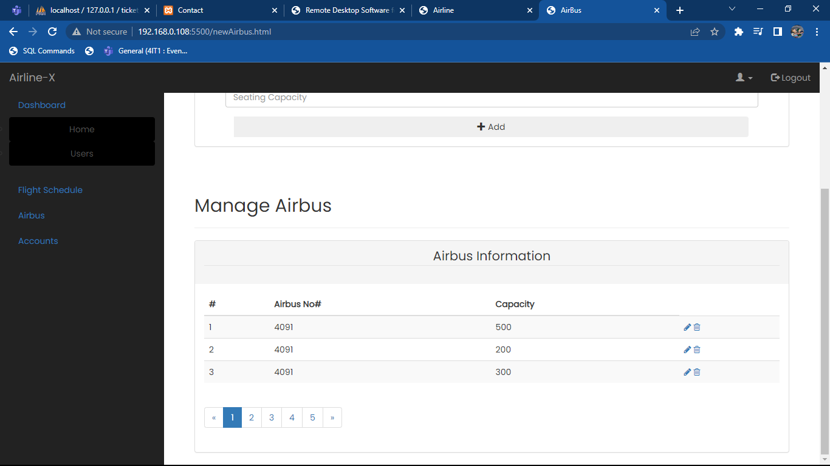

fig 7. 15 manage flights

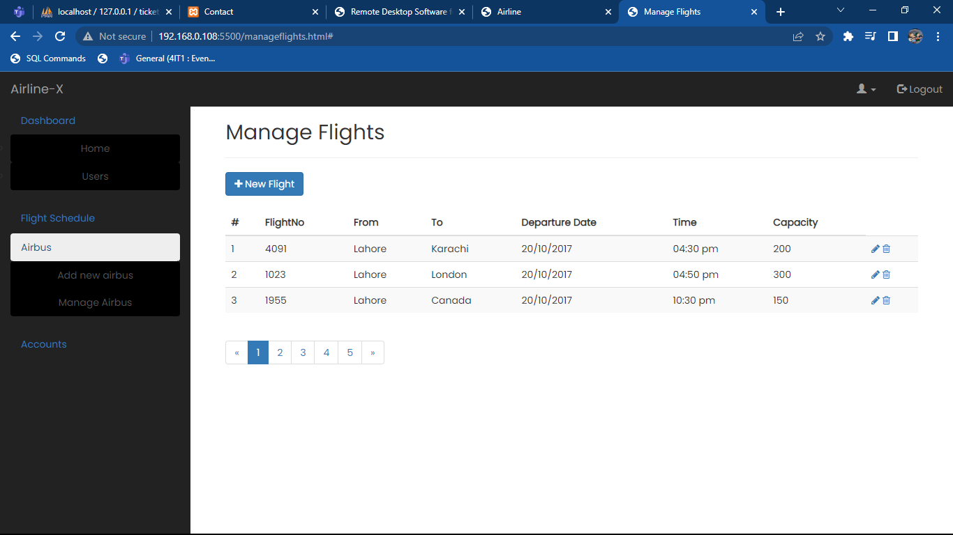

fig 7. 16 manage bus

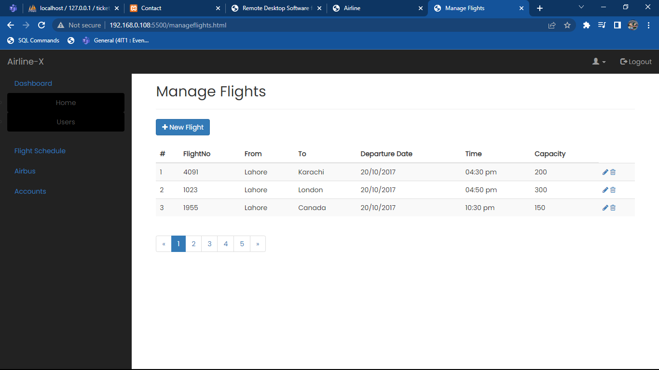

fig 7. 17 manage airb uses

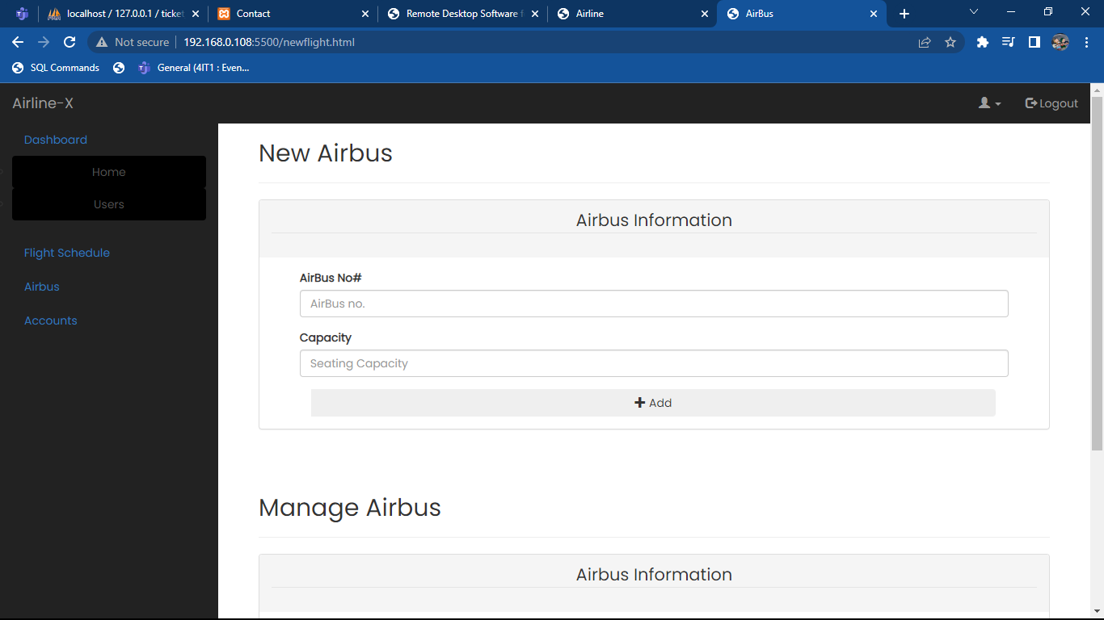

fig 7. 18 add airbuses

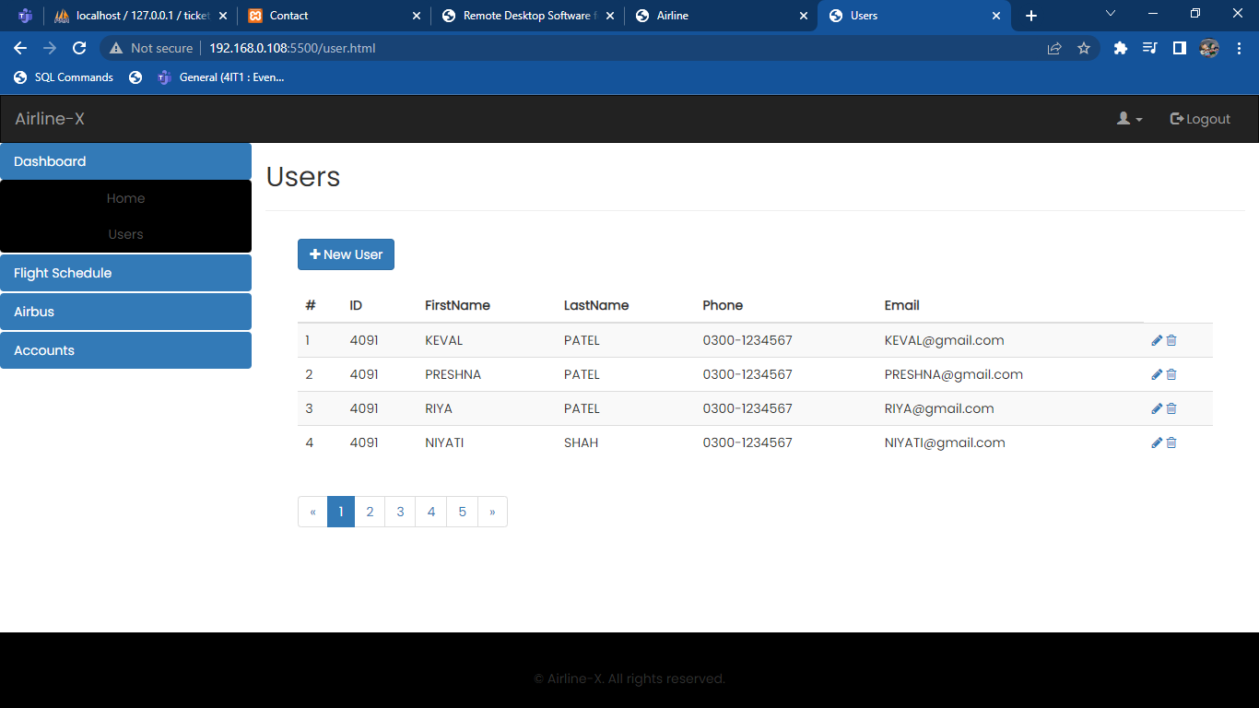

fig 7. 19 user data

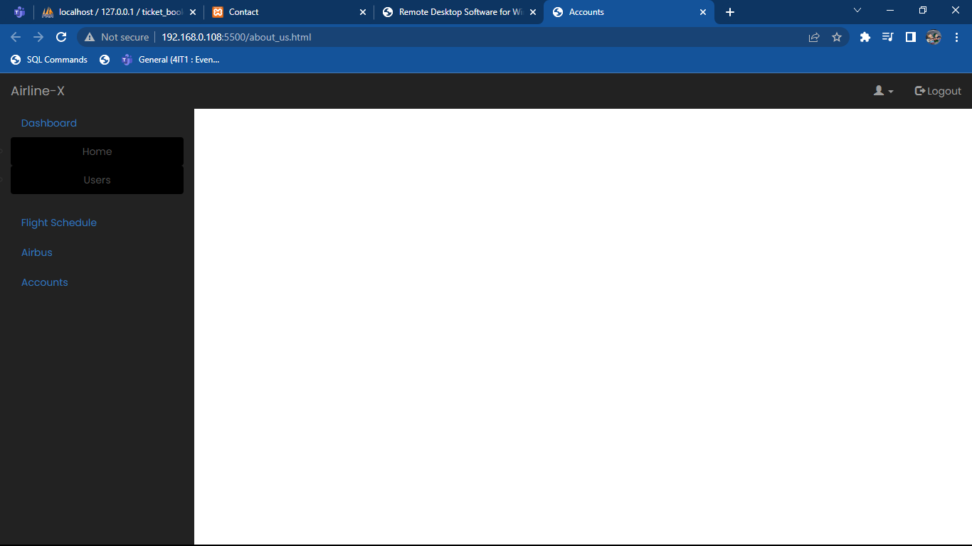

fig 7. 20 admin dashboard

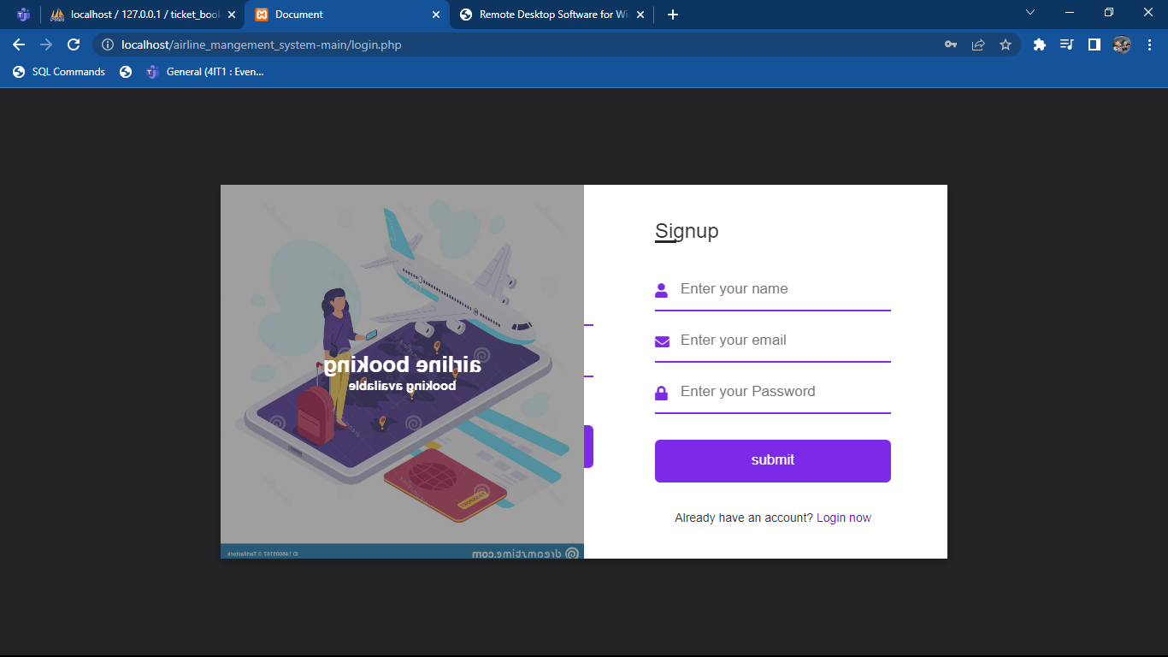

fig 7. 21 signup page

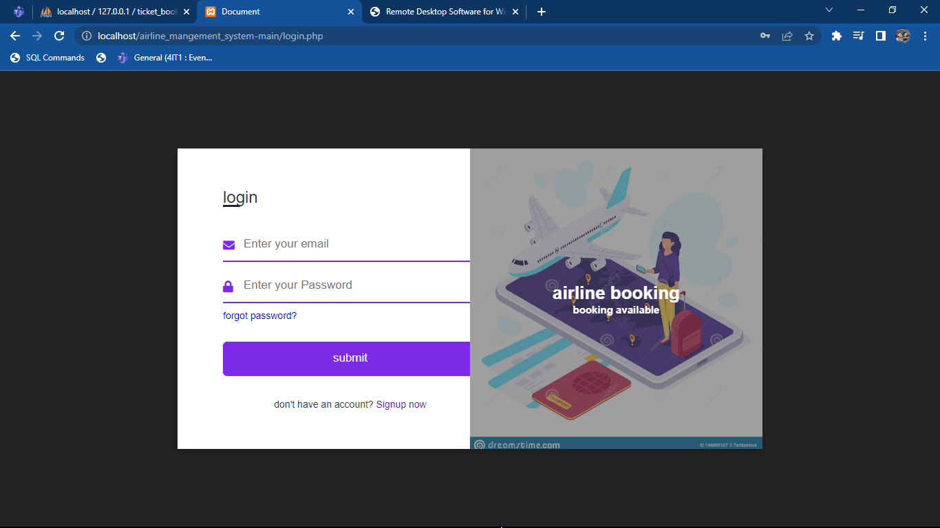

fig 7. 22 login page

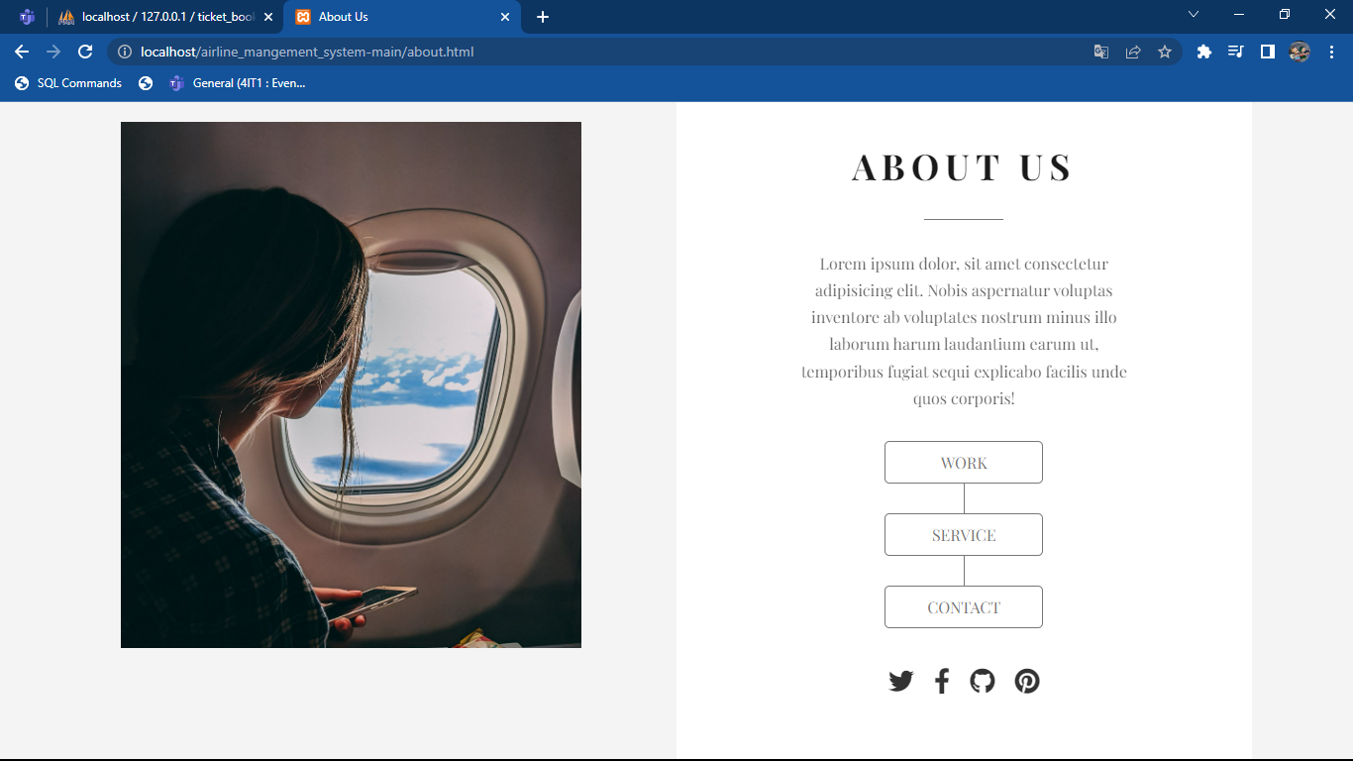

fig 7. 23 about us

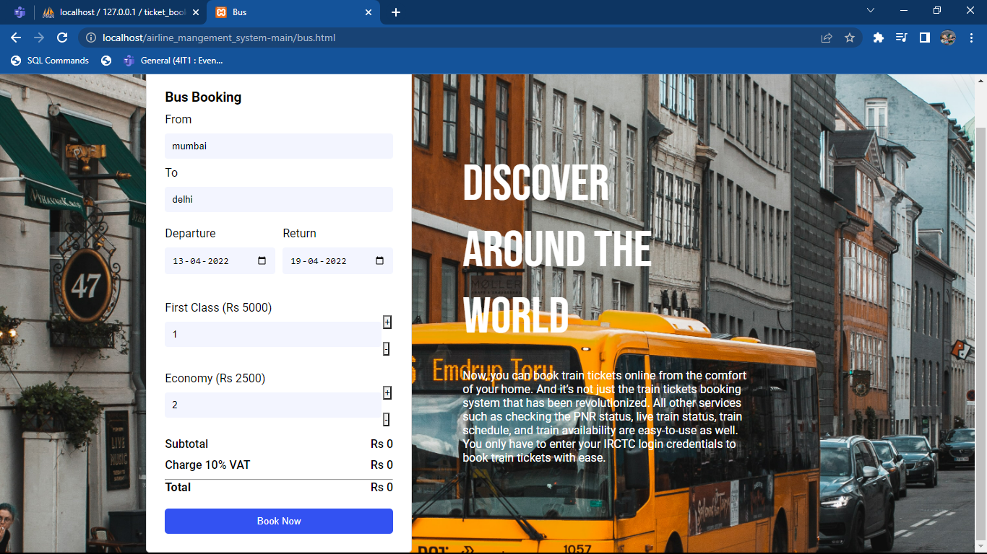

fig 7. 24 bus booking

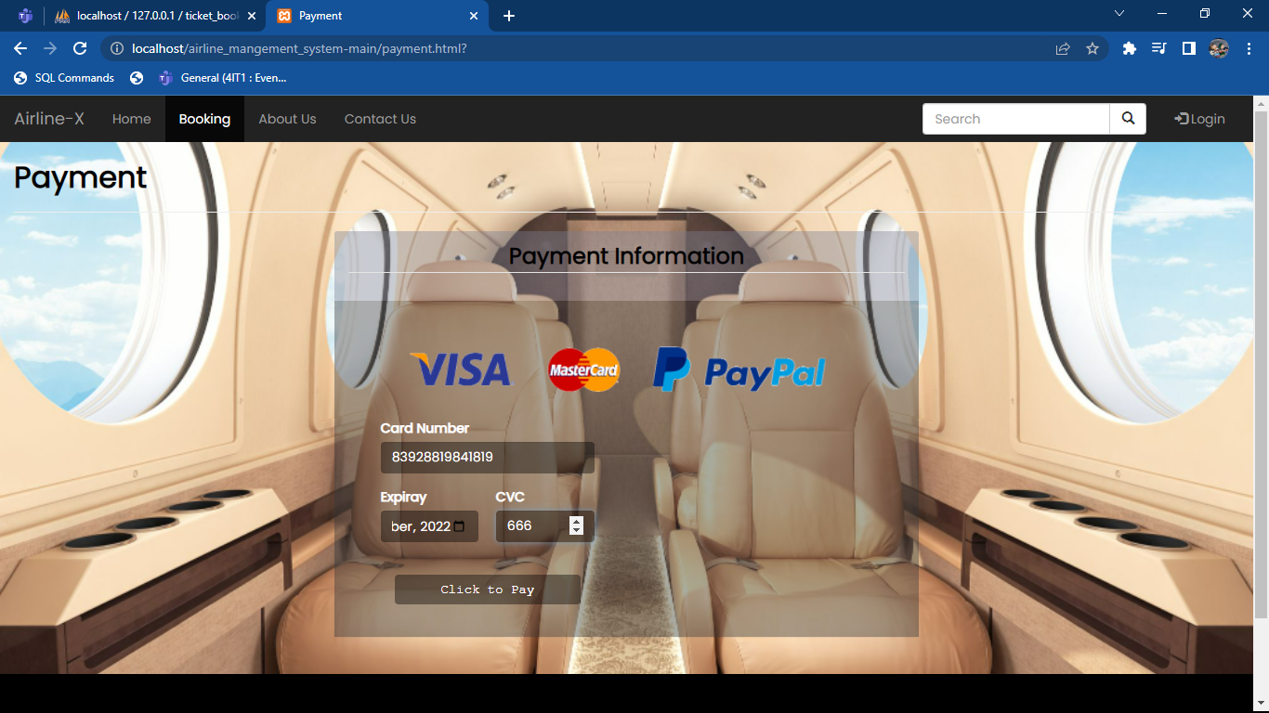

fig 7. 25 payment pages

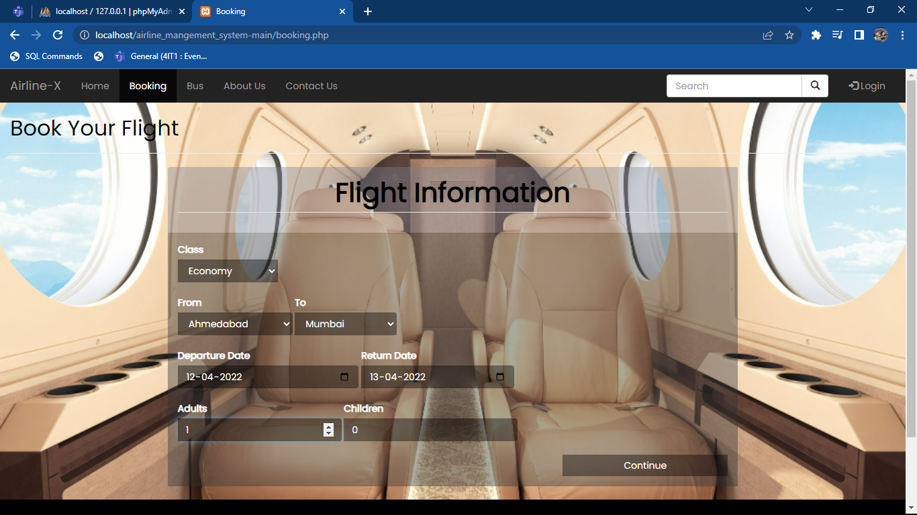

fig 7. 26 flights book

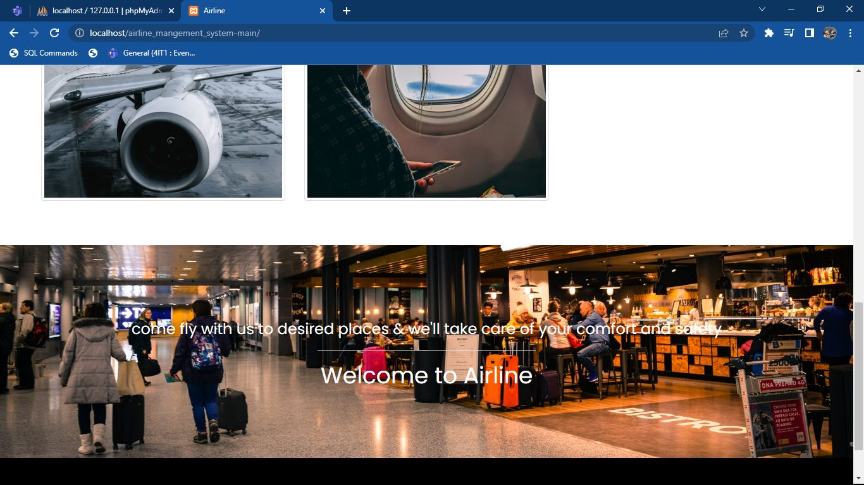

fig 7. 27 main page

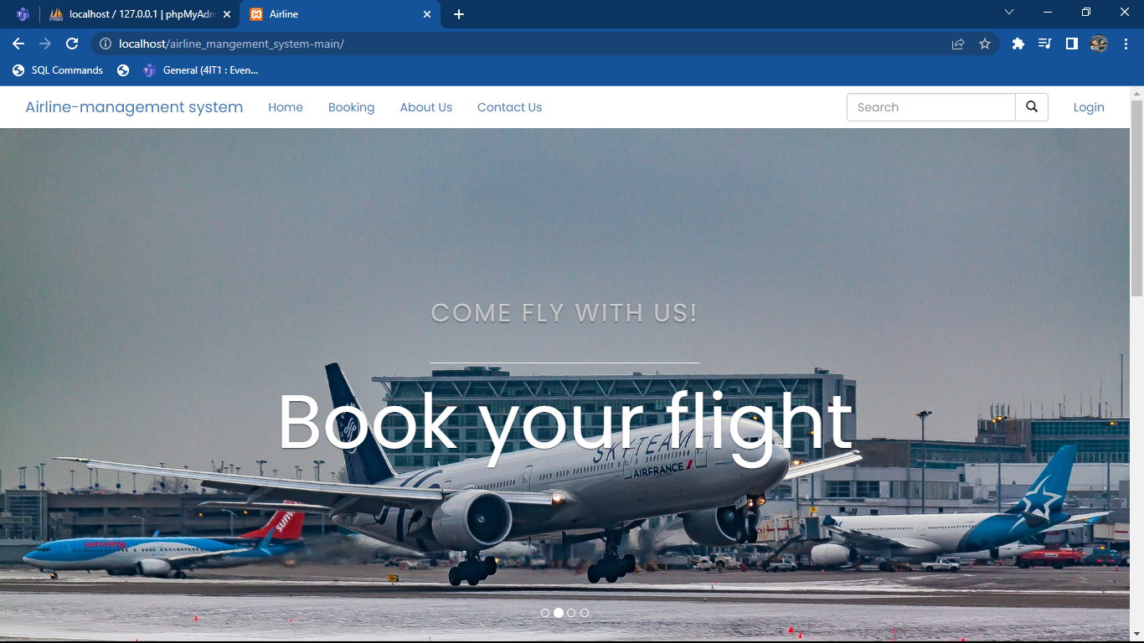

fig 7. 28 main page

**Chapter -8**

**Future Enhancements**

**FUTURE ENHANCEMENTS**

* The software has been developed in such a way that it can accept

modifications and further changes. The software is very user friendly and future any changes can be done easily.

* Software restructuring is carried out. Software restructuring modifies

source code in an effort to make it amenable to future changes. In general, restructuring does not modify the overall program architecture. It tends to focus on the design details of individual modules and on local data structure defined within modules.

* Every system should allow scope for further development or enhancement. The system can be adapted for any further development. The system is so flexible to allow any modification need for the further functioning of programs.
* Since the objectives may be brought broad in future, the system can

be easily modified accordingly, as the system has been modularized. The future expansion can be done in a concise manner in order to improve the efficiently of the system.

**REFERENCES**

1. <https://youtu.be/1SnPKhCdlsU>
2. <https://youtu.be/BsDoLVMnmZs>
3. <https://www.codecademy.com/catalog/language/html-css>
4. <https://www.guru99.com/php-tutorials.html>